Dummies guide for setting up AKROMA masternode

This guide assumes you have your vps already ordered and running and putty connected to vps.

If you haven't head over to https://www.digitalocean.com/products/linux-distribution/ubuntu/.

Their lowest droplet option will work just fine.

Now all things completed let’s copy and paste some commands into putty.

If you are using Ubuntu 14.04 LTS this will be required

sudo apt-get install systemd

Now let’s start Master node setup

Needed packages:

sudo apt-get install wget

sudo apt-get update && sudo apt-get install curl

now comes to interesting part

wget https://raw.githubusercontent.com/iandesj/scripts/master/masternode/setup.sh

chmod +x setup.sh

./setup.sh --systemd # this creates systemd service and uses default port 8545

sudo systemctl start masternode # this starts our master node service

sudo systemctl enable masternode # this will enable service to start at boot

sudo systemctl stop masternode # this stops our masternode service

systemctl status masternode # displays pageable log, pressing `Q` or `q`, or control + `C` will exit the status display

Masternode Registration

Registration of your node allows us to monitor uptime, as well as keep check of wallet balance to ensure you have the necessary collateral.

1) Login to https://dashboard.akroma.io

2) In side panel, visit “Masternodes” pane.

3) You should now see the “Create” link under the “Masternodes” heading, click this.

4) Once on the Create page, you’ll see several fields required for creation.

Overview of these fields

Enode Id: Unique public key for your node. We will discuss how to find this below.

Node IP Address: IP address of your node, remember that static IP mentioned above? This is that.

Node Port: Port used to perform periodic health checks on. Should be 8545 unless specified differently in initial node setup. Make sure this port is open to the outside.

Wallet Address: Akroma wallet address associated with your master node (used for pay outs, verification, and checks).

The Akroma team have written a utility script to assist obtaining this info if you don’t have it on hand.

Follow the instructions below to use.

wget https://raw.githubusercontent.com/iandesj/scripts/master/masternode/utils.sh

chmod +x utils.sh

./utils.sh --enodeId --nodePort --nodeIp

This command will output all the information required to create a masternode on Akroma dashboard, and will look like below.

Enode Id: 22b9949bbxxxxxxxxxxxxxxxxxxxxxxxxxxxxxxxxxxxxxxxxxxxxxxxxxxxxxxxxxxxxxxxxxxxxxxxxxxxxxxxxxxxxxxxxxxxxxxxxxxxxxxxxxxxxxxxxxxxxxxxxxxxcee27c946

Node Port: 8545

Node IP: xx.xx.xx.xx

~ $ ./utils.sh –nodePort xxxx # flags can be used individually

Node Port: 8545

~ $ ./utils.sh --help # this for help :)

Now lets head over to https://dashboard.akroma.io/dashboard/masternodes

Click + create master node

Fill in the required fields:

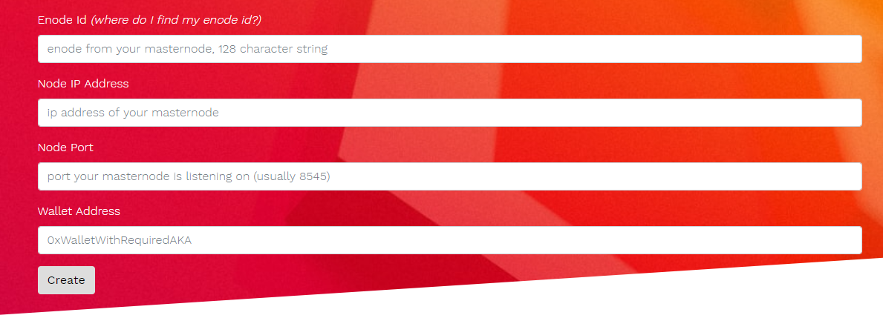

At this point, if all of the details are valid, you should have created a master node, yet to be “verified” as represented in “pending” status.

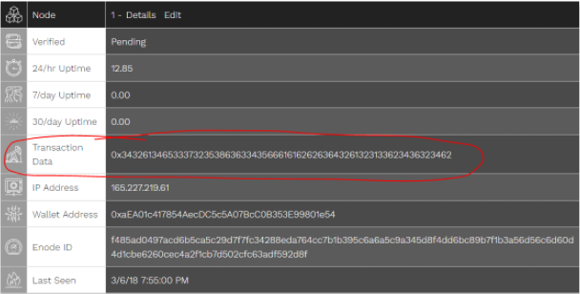

Masternode Verification

Verification of your masternode consists of one user-interaction,

this is sending a transaction in any amount of AKA **to and from the same wallet** that’s being used

for the masternode with the value of Transaction Data (represented as TransactionData)

on the unverified masternode detail page.

Copy this value and paste it into the data input in your transaction (not currently available in the Android wallet).

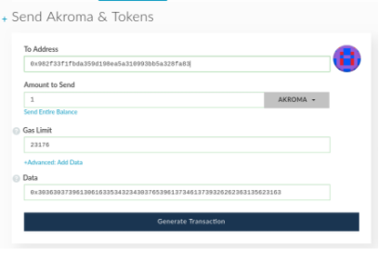

At this point, if your transaction has been sent, and your wallet meets the minimum collateral requirement for verification, the master node should be verified shortly.